**EEE361**

**ASSIGNMENT**

**SET-2**

1. An expression for an electric field is given below

$E=20Cos\left(ωt-2x-3z\right)$ ay V/m

Is incident on a dielectric slab (Z ≥ 0) 5.5With µr = 1.0 and εr = 2.5 Find:

1. The polarization of the wave
2. The angle of incidence
3. The reflected E and H field
4. The transmitted E and H field

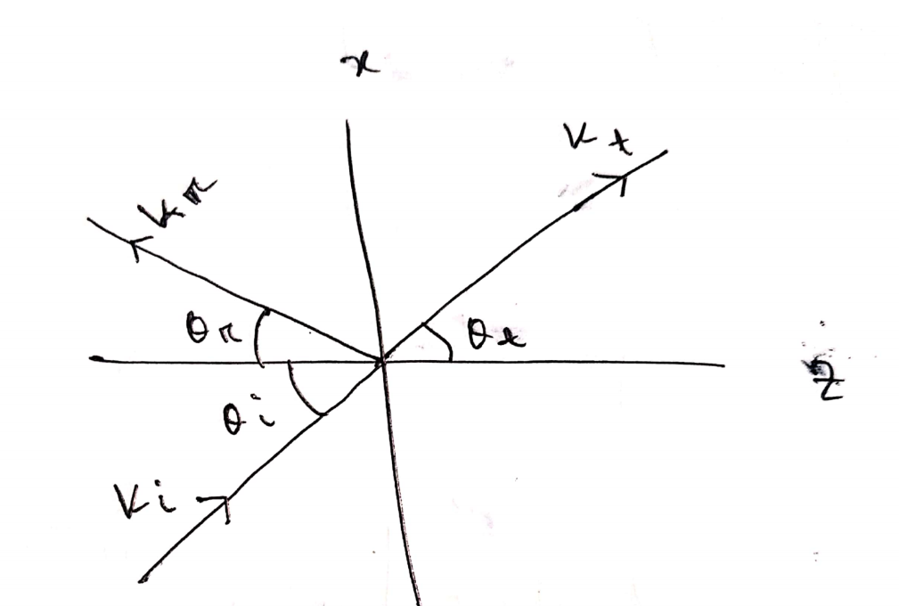

Fig: Problem 1

1. The magnetic field in a region is given by the expression

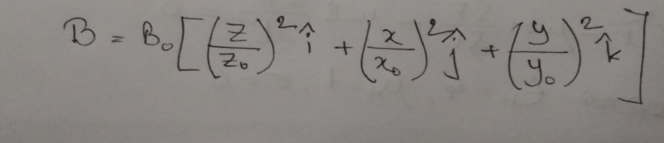

* 1. Using the knowledge of Maxwell’s equation, find the curl of the induced electric field at that location.
  2. The electric field has 3 components, Ex (in the direction of x0-,Ey (in the direction of y), Ez (in the direction of z). Using the result from part (a), find the x component of the electric field if the y component is assumed to be zero.

1. For time varying fields: Find which if the following equations are not satisfy Maxwell’s Equation. Also state why the expression/s don’t satisfy Maxwell’s Equation? (Show Calculation)
$∇∙J + \frac{∂ρ_{v}}{∂t} = 0$

$∇∙D = ρ_{V}$

$∇∙ E = - \frac{∂B}{∂t}$

$\oint{H∙ dl} = \int{(σE + ε\frac{∂E}{∂t}} ) ∙ dS$

$\oint{B∙dS} = 0$

2. The total electromagnetic energy is given below

W= $\frac{1}{2}\int{\left(E.D+H.B\right)dv}$

Show from Maxwell’s Equation that

$$\frac{∂W}{∂t} = - \oint{(E × H ∙ dS - \int_{V}{E∙ J dv}}$$

1. An expression for an electric field is given below

$E=20Cos\left(ωt-2x-3z\right)$ ay V/m

Is incident on a dielectric slab (Z ≥ 0) With µr = 1.0 and εr = 2.5 Find:

1. The polarization of the wave
2. The angle of incidence
3. The reflected E and H field
4. The transmitted E and H field
5. a) Given the magnetic field intensity

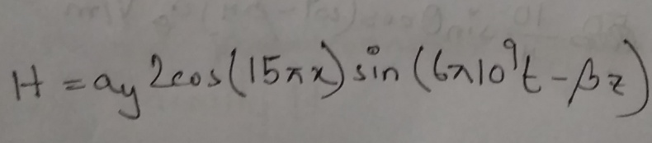

in air. Using this information and the knowledge of Maxwell’s equation, find the electric field intensity E and the constant β.

1. In free space, the electric field intensity is defined by

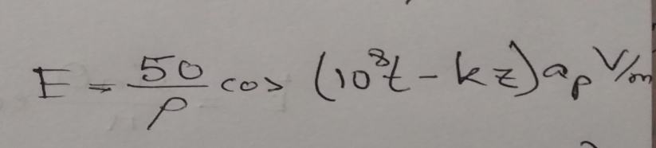

Using this information and the Maxwell’s equation,

find the constant k, displacement current density, Jd and magnetic field intensity H.